BARNET ALLOTMENT FEDERATION
HORTICULTURAL SHOW 2016
SATURDAY AUGUST 20th 12.00 – 5.30
RATHBONE ALLOTMENTS PAVILION
RYALLS COURT
OAKLEIGH ROAD SOUTH
N20 0RY

SETTING UP: Fri. 19th 12.00 – 2.00
STAGING: Fri. 2.00 -5.00 / 6.00 – 8.00 & Sat. 20th 9.00 – 10.00
JUDGING: Sat. 20th 10.30 -12.00
PRIZEGIVING & AUCTION: Sat. 20th 4.00 - 5.30
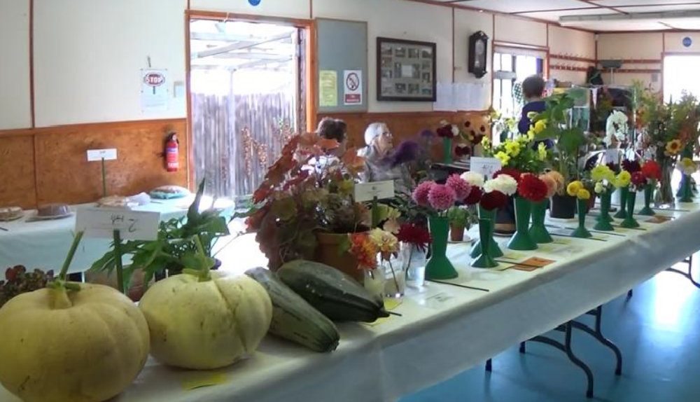

- Classes in Vegetables, Fruit, Cut Flower, Potted Plants, Domestic, are open to all Federation allotment holders and their immediate families* who wish to submit exhibits.
*The allotment holder, their spouse, children, parents and grandparents only

- All exhibits presented for competition must be the property of the exhibitor, and have been in their possession for at least ONE month prior to the Show. All exhibits must be the sole effort of the exhibitor.

- A JUNIOR for the purpose of this show is a child under sixteen years of age on 1st August 2016. JUNIORS’ age must be shown on entry forms. JUNIORS may enter adult classes, where no JUNIOR class is specified.

- Judging will be by independent judges. THE JUDGES’ DECISION IS FINAL. The Organisers reserve the right to decide any other points in dispute, and may refuse any entry, and, in the event of such refusal, is not required to give any reason or explanation. All exhibits will be judged in accordance with the handbook of the relevant specialist society.

- In any competition, any complaint, other than against the decision of the judge, must be made in writing with a deposit of £5 sterling before 3pm Saturday 20th August 2016; Deposit will be refunded if the complaint is upheld.

- The exhibition area will close to the general public immediately after the completion of the prize-giving to allow exhibitors to remove their exhibits from the show bench in preparation for the auction which follows the prizegiving. Any item remaining on the show bench which has not been reserved will be auctioned. Exhibits can be removed from the exhibition area after closure.

- Entry forms and fees should be sent by post or email to the address shown on the entry form before 6pm Tuesday 16th August 2016. RESERVED items must be clearly marked on the entry form. All cheques\postal orders sent in payment of entry fees or donations should be crossed and made payable to BARNET ALLOTMENT FEDERATION.

- Whilst all reasonable precautions will be taken for the safety of exhibits, competitors are reminded that valuable articles should not be used in displays, or if used, should be covered by your household insurance.

- Entry fees:
Adult Classes: 6 entries £2.50 Single entry 50p Junior Classes: Single entry 25p

- No exhibitor may be awarded more than one money prize in any one class.

10a. Points in all classes to count towards special awards and certificates.
POINTS ADULT JUNIOR POINTS ADULT JUNIOR
FIRST 6 points £2.00 £1.00 VHC 3 points certificate certificate
SECOND 5 points £1.50 £0.75 HC. 2 points - - - - - - certificate THIRD 4 points £1.00 £0.50 C. 1 points - - - - - - certificate
Donated items may be awarded in place of monetary prize.

- No exhibitor may make more than 2 entries per class but more than one member of the same household may enter the same class.

- Exhibits MUST BE correctly named or mark ‘Name unknown’ on the cards provided. Failure to do so may result in the judge awarding an NOT ACCORDING TO SCHEDULE (NAS).

- All exhibits must be exhibited in a clean state, and displayed on doilies, paper plates, or in vases, etc. (as appropriate) supplied by the organisers.

14. TIMINGS:
Entries forms to be received by Tuesday 16th August before 6pm
Setting up Friday 19th 12pm – 2pm
Staging will be from Friday 19th August from 2pm to 5pm – 8.00
Saturday 20th August from 9am to 10am.
Late entries will not be accepted after 9.15am on Saturday 20th August.

Judging will take place Saturday 20th August from 10.30am to 12noon.
Collection of prize money from 3pm onwards
Open for viewing from 12.00 to 5.30pm
Prize giving & auction from 4pm onwards

- Only persons authorised by the organiser may remain in the exhibition area during the judging.

- Prize money not collected by 5.30 on Saturday 20th August will be regarded as a donation to the Barnet Allotment Federation.

- Additional rules are contained within the Division details.

SPECIALS - DIVISION ‘B’
11 ALLOTMENT SOCIETY DISPLAY. (NON-COMPETITIVE and FREE ENTRY) Allotment Societies in the Borough of Barnet are invited to provide a display of allotment grown flowers, vegetables, fruit and jams, wines etc. made from allotment produce, and any items appertaining to allotment gardening. (i.e. photographs of sites, mugs, etc.). Containers etc. are to be supplied by the Society. The display must be contained within an area 1.82 x 1.82 x 1.52m (w x h x d).

VEGETABLES - DIVISION ‘C’
21 A COLLECTION OF VEGETABLES 3 distinct kinds, quantities as per individual classes.
Area, 90cm by 120cm (3ft x 4ft).
22 A COLLECTION OF SALADING VEGETABLES 3 distinct kinds, 3 of each.
Area 60 x 60cm (2ft x 2ft).
23 A COLLECTION OF POTATOES 3 distinct varieties, 3 of each on paper plates.
24 A COLLECTION OF ONIONS 4 over 250g. 4 under 250g. Dressed.
25 TRUG of MIXED VEGETABLES Not less than 6 varieties.
26 BEANS, Runner Qty 6
27 BEETROOT, Globe and cylindrical Qty 3 with 75mm of foliage and clean tap root.
28 CABBAGES, Green, red or Savoy Qty 2 one variety with 75mm of clean stalk.
29 CARROTS, Long, pointed, intermediate Qty 3 with 75mm of foliage.
30 CUCUMBERS, House or frame Qty 2
31 LETTUCE Qty 2 with clean root attached.
32 MARROWS (including SQUASHES) Qty 2 not exceeding 30cm in length.
33 ONIONS Qty 4 under 250g, dressed.
34 ONIONS Qty 3 over 250g, dressed.
35 PEAS Qty 6 pods with bloom attached.
36 POTATOES, White or coloured Qty 3 one cultivar only.
37 SHALLOTS, Exhibition Qty 6 dressed.
38 SHALLOTS, Pickling Qty 6 under 38mm in diameter and dressed.
39 SWEETCORN Qty 2 with silks and green husk attached.
40 TOMATOES, Medium Qty 4 approximately 65mm diameter.
41 TOMATOES, Small Qty 10 Not exceeding 35mm diameter.
42* ANY OTHER VEGETABLE Not mentioned above. Qty as per RHS Show handbook
43 JUNIOR CLASS A funny face made of vegetables (under 7 years old).
44 JUNIOR CLASS An animal made of vegetables (between 7 and 11 years old)
45 JUNIOR CLASS An animal made of vegetables (between 12 and 16 years old
46 JUNIOR CLASS Allotment or garden in a seed tray (under 7 years old).
47 JUNIOR CLASS Allotment or garden in a seed tray (between 7 and 11 years old).
48 JUNIOR CLASS Allotment or garden in a seed tray (between 12 and 16 years old).
49 NON COMPETITIVE VEGETABLE CLASS
(a) The longest runner bean (b) Any odd shaped vegetable (c) Heaviest marrow
VEGETABLE AWARDS
BEST EXHIBIT (ADULT) CONSTABLE CUP
BEST EXHIBIT (JUNIOR) MUSWELL HILL RECORD CUP
MOST POINTS (ADULT) CERTIFICATE
MOST POINTS (JUNIOR) CERTIFICATE

FRUIT - DIVISION ‘D’

All fruit classes to be displayed on appropriate sized paper plates.
61 APPLES, Cooking Qty 3 with stalks attached.
62 APPLES, Dessert Qty 3 with stalks attached.
63 BLACKBERRIES Qty 12 with husk attached.
64 PLUMS Qty 4 with stalks attached.
65 RASPBERRIES Qty 12 with husk attached.
66* ANY OTHER FRUIT Not mentioned above. i.e. damsons, grapes, melons etc.
67 JUNIOR CLASS - A PLATE OF FRUIT Sufficient to fill a 23cm (9in) plate.

FRUIT AWARDS
BEST EXHIBIT (ADULT) BREWER CUP
BEST EXHIBIT (JUNIOR) RANDALL CUP
MOST POINTS (ADULT) CERTIFICATE
MOST POINTS (JUNIOR) CERTIFICATE

CUT FLOWER - DIVISION 'E'
90 SWEET PEAS One vase of six mixed spikes
91 DAHLIAS, Giant and/or large Three vases, 1 bloom per vase.
92 DAHLIAS, Medium One vase of 3 blooms. One variety.
93 DAHLIAS, Small One vase of 3 blooms. One variety.
94 DAHLIAS, Ball One vase of 3 blooms. One variety.
95 DAHLIAS, Miniature One vase of 3 blooms. One variety.
96 DAHLIAS, Pompon (under 52mm) One vase of 5 blooms. One variety.
97 DAHLIAS, Not specified above One vase of 5 blooms. One variety.
98 CHRYSANTHEMUMS, Spray One vase of 3 sprays.
99 PELARGONIUMS (GERANIUMS) One vase of 3 stems, one or more varieties.
100 FUCHSIA 6 florets, at least 2 varieties. Container not supplied.
101 GLADIOLI One vase of 3 spikes, one or more varieties.
102 DIANTHUS (CARNATION/PINKS) One vase of 3 stems, one or more varieties.
103 VASE OF ANY CUT FLOWERS Not specified above.

104 JUNIOR FLOWERS – ANNUALS In a clear glass jar (all ages).
105 JUNIOR FLOATING FLOWER Bowl not to exceed 23cm (9 inches) (all ages).

CUT FLOWER AWARDS
BEST EXHIBIT (ADULT CONSTABLE ROSE BOWL
BEST EXHIBIT (JUNIOR) HALSTEAD CUP

BEST EXHIBIT OF DAHLIAS CERTIFICATE
MOST POINTS (ADULT) CERTIFICATE
MOST POINTS (JUNIOR) CERTIFICATE

POTTED PLANTS - DIVISION ‘F’
121 PELARGONIUMS (GERANIUMS) In flower
122 FUCHSIA In flower.
123 FUCHSIA COLLECTION 3 different varieties in separate pots. Any size.
124 UNUSUAL PLANT e.g. air plant, orchid, Venus flytrap etc.
125 CACTUS or SUCCULENT Any size pot.
126 BEGONIA In flower in any size pot.
127 BONSAI Un-restricted.
128 POT PLANT IN FLOWER Not mentioned above, un-restricted size.
129 POT PLANT FOR FOLIAGE Not mentioned above, un-restricted size.
130 JUNIOR - POT PLANT – FOLIAGE You have cared for.
131 JUNIOR - POT PLANT – FLOWER You have cared for.

POTTED PLANT AWARDS
BEST EXHIBIT (ADULT) INTER SOCIETY FLORAL ART
BEST EXHIBIT (JUNIOR) CERTIFICATE
MOST POINTS (ADULT) CERTIFICATE
MOST POINTS (JUNIOR) CERTIFICATE

DOMESTIC - DIVISION ‘G’
All exhibits in classes 141 to 144 are to be in 1lb/453 gram jars, have a clear cover, and be named and dated.
Classes 145 to 148 and 152 and 153 are to be exhibited on paper plates supplied by the organisers.
141 One jar of home made seed or stone fruit jam.
142 One jar of home made fruit jelly.
143 One jar of home made orange marmalade.
144 One jar of home made chutney or pickle with vinegar proof seal.
145 One small home made bread – any kind.
146 Six home made plain scones.
147 Six home made shortbread fingers.
148 One home-made Victoria Sponge - butter or jam filling.
149 One home made apple pie on exhibitors own receptacle. (Maximum size 10”).
150 One rich fruit cake on cake board - Christmas cake recipe.
151 One celebration cake on cake board - judged on decoration only.
152 JUNIOR (under 12 years old) Six plain scones.
153 JUNIOR (12 to 16 years old) Six fruit scones.

DOMESTIC AWARDS
BEST EXHIBIT (ADULT W. R. V. S. CUP
BEST EXHIBIT (JUNIOR) JUNIOR CHEF CUP
MOST POINTS (ADULT) CERTIFICATE
MOST POINTS (JUNIOR) CERTIFICATE

DONATED EXHIBITS WILL BE AUCTIONED AT THE END OF THE SHOW

